**StrikeTec Workflow_V1**

Revision History

|  |  |  |  |
| --- | --- | --- | --- |
| **Date** | **Content (Changed)** | **Version** | **Author** |
| 2017/08/03 | Complete initial workflow | 1.00 | Hu |
| 2017/08/03 | Add some comment | 1.01 | Wes |

Contents

Introduction 2

Screens and Features 2

Registration 2

Main Screen 8

Home 8

Guidance 12

Training 14

Challenge 16

More 22

Contents of Figures

Figure 1. Splash Screen 3

Figure 2. Login Screen 3

Figure 3. Tip Screens 4

Figure 4. Forgot Password 4

Figure 5. Verify Code Screen 5

Figure 6.Reset Password 5

Figure 7. Forgot password failed 5

Figure 8. Signup 6

Figure 9. My Profile Screen 6

Figure 10.Connect Wearable Screen 7

Figure 11. Spectator Confirm 7

Figure 12.Set Sensor Screens 8

Figure 13. Plans Screen 8

Figure 14. Follow People Screen. 8

Figure 15.Home-FeedScreen 9

Figure 16. Home-MyProgress 10

Figure 17. Home-Explore&Leaderboard 10

Figure 18. Message Screeen 11

Figure 19. Notification Screen 12

Figure 20.Challenge, Chat Dialog 12

Figure 21. Guidance 13

Figure 22. Video Play Screen 13

Figure 23. Search Video Screen 14

Figure 24. Favorite Video Screen 14

Figure 25. Training Screen 15

Figure 26. Quick Start Preset Screen 15

Figure 27. Round Training Preset Screen 15

Figure 28. Scripted Rounds Page 16

Figure 29. Combo Sets Screen 16

Figure 30. Challenge Main Screen 17

Figure 31. Received Battles 17

Figure 32. Sent Battles 17

Figure 33. Finished Battles 18

Figure 34. Battle Detail Screen 18

Figure 35. Battle Result Screen 19

Figure 36. New Battle Screen 19

Figure 37. Select Battle Content Screen. 19

Figure 38. Battle Description Screen. 19

Figure 39. Battle Purchase 20

Figure 40. Tutorial Purchase 20

Figure 41. Tournaments Purchase 20

Figure 42. Tournamt Screen 21

Figure 43. Tournament Leaderboard Tab 21

Figure 44. Tournament My Connection Tab 21

Figure 45. Tournament Detail Screen 22

Figure 46. Game Tab 22

Figure 47. More Screen 23

Figure 48. Settings Screen 23

Figure 49. Subscription Screen 23

Figure 50. Store Screen 24

Figure 51. HelpCenter Screen 24

Figure 52. About Screen 24

Figure 53. Other users Profile 25

Figure 54. Detailed Profile Screen 26

Figure 55. Notification Settings Screen 27

Figure 56. Connected Accounts Page 27

Figure 57. Sensor Manage Screen 28

Figure 58. Statistics Screen 28

Figure 59. Acheivement Screen 28

Figure 60.Social Followers Screen 29

Figure 61. Social Following Screen 29

Figure 62. Social Challenge Screen 29

Figure 63. Edit profile Screen 30

Figure 64. Contact Us 31

# Introduction

This document is including main screens and features for version1.

# Screens and Features

## Registration

## C:\Users\Super\Desktop\StrikeTec\NewStriketec\invisionscreens\apple-touch-startup-image.png

This screen is Splash Screen.

After run this screen , app will go to

* If user already used this app after sign in, then main screen(Figure 16. Home-MyProgress) will be showed.
* If user never logged in, then login screen will be showed.(Figure 2. Login Screen)

Figure 1. Splash Screen

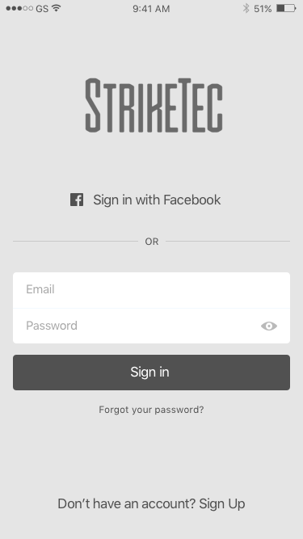

This is Login Screen.

* sign in with facebook and email&password
* go to forgot password page(Figure 4. Forgot Password), go to sign up page(Figure 8. Signup)

after sign in success, if this is first login then will go to tip page(Figure 3. Tip Screens), otherwise will go to main screen(Figure 16. Home-MyProgress)

*** required apis ***

* sign in api with email & password and facebook

maybe api will include sign in type to know this user is singing in with facebook or email&password

Figure 2. Login Screen

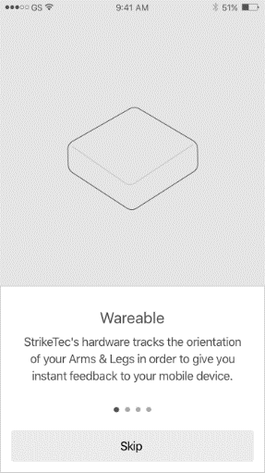 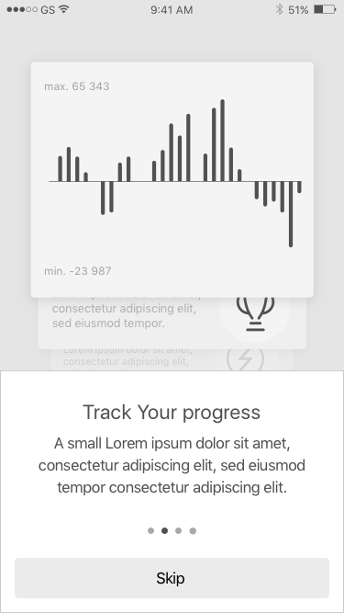

This 4 screens are Tip screens.

These screens can be showed only when user logged in first time in this device.

**** api *******

Don’t need any apis here.

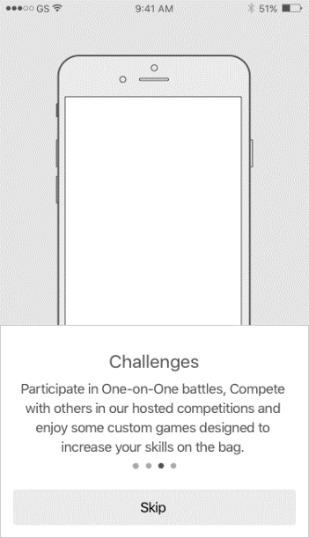 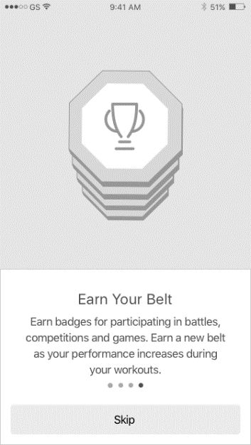

Figure 3. Tip Screens

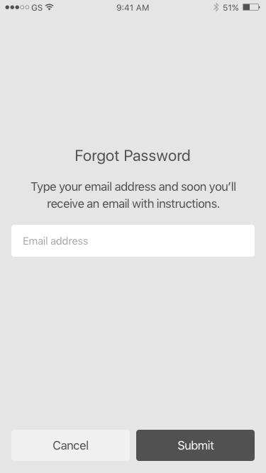

This screen is forgot password screen.

user will input email address to reset password for account with this email.

if user click «cancel», then goes to login screen(Figure 2. Login Screen).

if user click «submit», then app will call forgot password api.

***** api ****

server will check user who is registered with this email is exist or not.

if exist, server will send verify code to this email (6 digits).

in any case, we need response message like «verify code is sent», or «user with this email is not exist», or some thing.

if server response is success, then will go verify screen(Figure 5. Verify Code Screen), if fail will go to fail screen(Figure 7. Forgot password failed).

Figure 4. Forgot Password

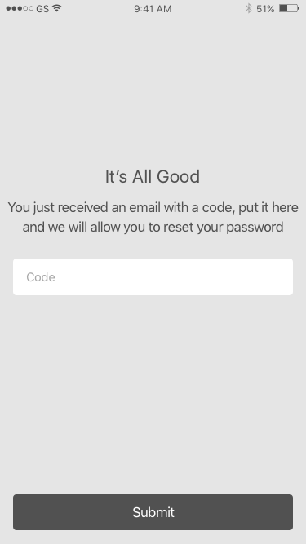

This Screen is verify code screen.

if user click «continue», then will call verify code api.(«submit» will change as «continue»)

*** api ****

parameters can be email and verify code.

server will compare verifycode which is saved in server for this user and will send response false or true.

if success, will go to reset password screen(Figure 6.Reset Password).

if fail, will show message and try to again.

Figure 5. Verify Code Screen

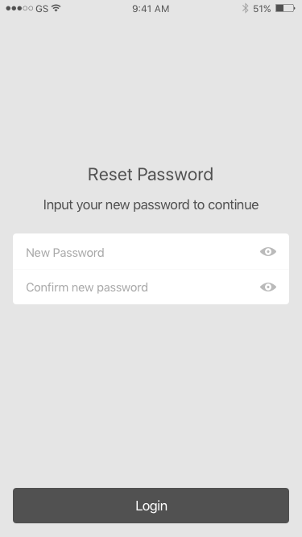

This Screen is reset password.

if user click «Submit», then app will compare new password and confirm password. («login» will be changed as «submit»)

*** api ***

parameters will be email and new password, then server will change existing password to new password.

server will respond success or fail.

if success, will go to login screen(Figure 2. Login Screen).

if fail, will show message.

Figure 6.Reset Password

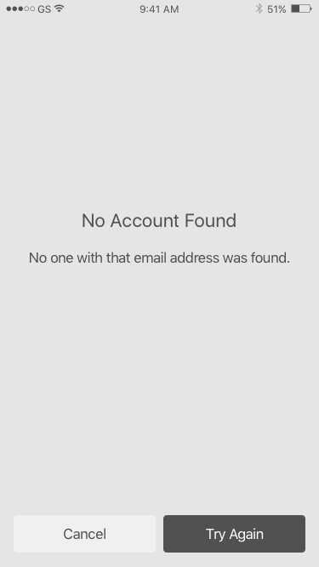

If user click “Try Again”, will go to forgot password screen(Figure 6.Reset Password).

if user click “Cancel”, will go to login screen(Figure 2. Login Screen)

Figure 7. Forgot password failed

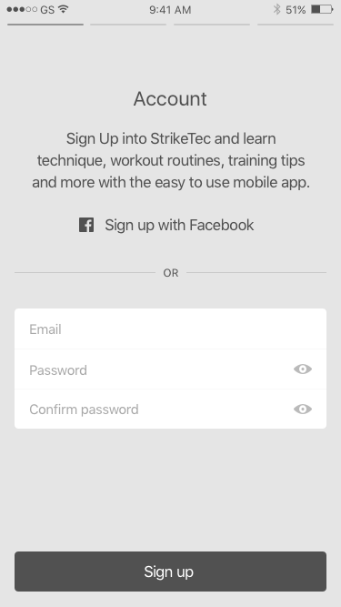

This Screen is Signup Screen.

user can sign up with facebook and email&password.

if user click signup with facebook , then app will get user email and some info like first name and last name, profile, etc

**** api ****

app will send email as parameter to check if user who is registered with this email is exist or not.

if signup is available, then app will go to my profile screen(Figure 9. My Profile Screen).

Figure 8. Signup

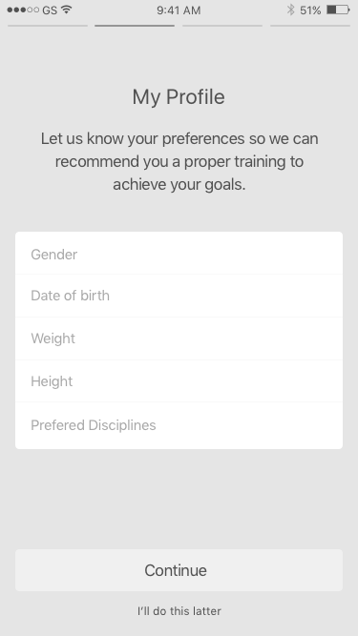

This screen is My profile screen.

«Prefered Disciplines» will be changed as «stance».

**** api ***

any api is not needed here.

If user click «Continue» , will go to «Connect Wareable» screen(Figure 10.Connect Wearable Screen).

if user click «i’ll do this later», will skip or can call sign up api

Figure 9. My Profile Screen

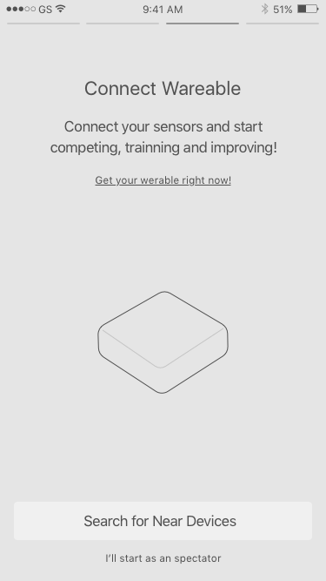

This screen is connect sensor screen.

When user don’t have sensors, user can signup as Spectator user.

if user click «Search for New Devices», then will go search sensor screen(Figure 12.Set Sensor Screens).

if user click «I’ll start as a spectator», then will show confirm screen.(Figure 11. Spectator Confirm)

*** api ***

don’t need api here, but user will have «spectator» as one field.

this is emportant field, because spectator user don’t have full function in app.

Figure 10.Connect Wearable Screen

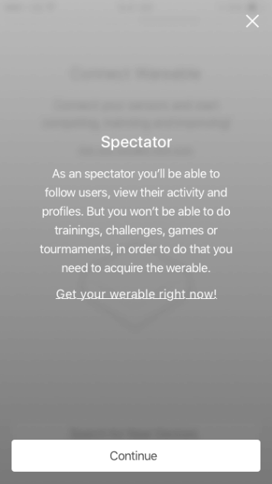

This screen is spectator confirm Screen.

If user click «get your wearable right now”, then will go to website to buy sensors.

if user click “Continue”, will call sign up api.

*user don’t need to plans because this user don’t have sensors.

*** api ***

sign up api is needed here.

if sign up success, will go to login screen (Figure 14. Follow People Screen.)

Figure 11. Spectator Confirm

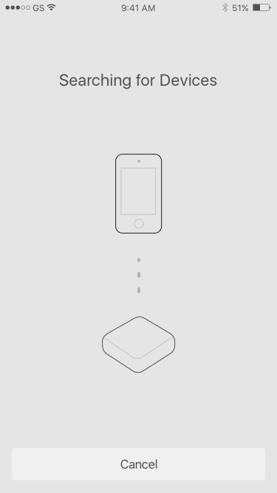 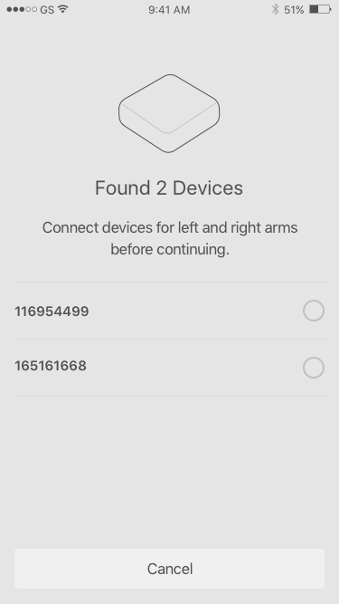

These 4 screens is for set sensors.

app will enable Bluetooth and will try to find sensors.

if found sensors, then will go to next screen to show sensor ids.

user can select sensor to set up hand or kick.

in final screen, if user click “continue “ , then will show “Plans” screen(Figure 13. Plans Screen) or follower screen(Figure 14. Follow People Screen.)

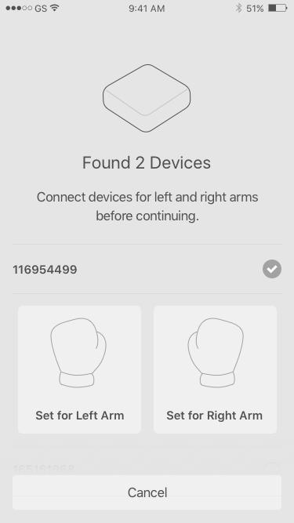 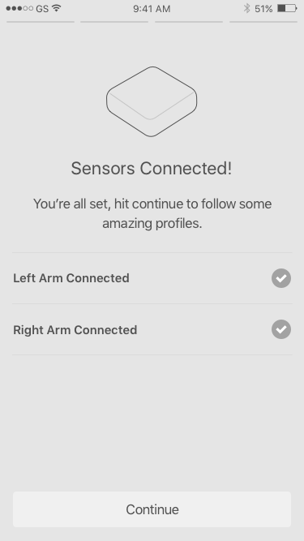

Figure 12.Set Sensor Screens

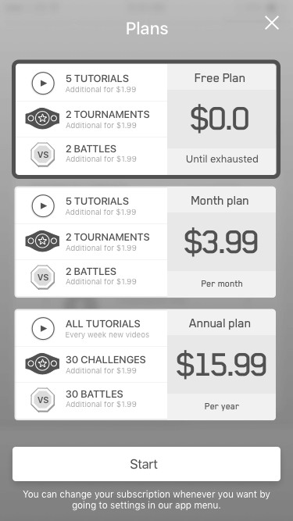

for every user, server will provide free plans, like a few tutorials, a few battles,…

user can buy items with through iap(in app purchase.)

if user click “start”, then app will call sign up api to register this user.

if success, app can go to login screen(Figure 2. Login Screen) or can go to main screen(Figure 16. Home-MyProgress).

Figure 13. Plans Screen

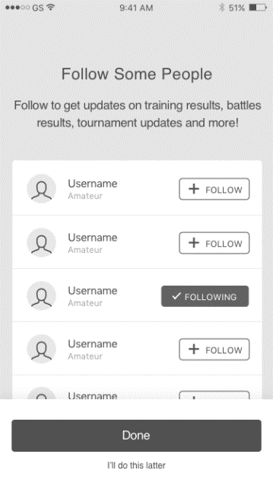

User can select follow button to follow people.

Click “Done”, will go to “Plans” screen.(Figure 13. Plans Screen)

Figure 14. Follow People Screen.

## Main Screen

### Home

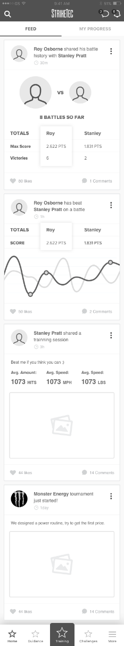

Main Screen is including 5 tabs which are “Home”, “Guidance”, “Training”, “Challenge”, “More”

“Home” tab is default tab and “Training” tab is always the larger tab, each tab that is selected will be highlighted.

This screen is the feed screen for current user.

we will add new tab for following users feed.(own feed: your feed)

*** api ***

* get own feed
* get following user’s feed

all apis will have start id, and count as parameter, like 25

server will send 25 feeds at once for every call (from “id” to “25 + id”)

if user click search, app will go “explore” and “leaderboard” screen(Figure 17. Home-Explore&Leaderboard).

if user click chat icon, then will go to chat screen(Figure 18. Message Screeen).

if user click notification icon, then will go to notification screen(Figure 19. Notification Screen).

if user click “3 dot icon”, then will show dialog(Figure 20.Challenge, Chat Dialog).

Figure 15.Home-FeedScreen

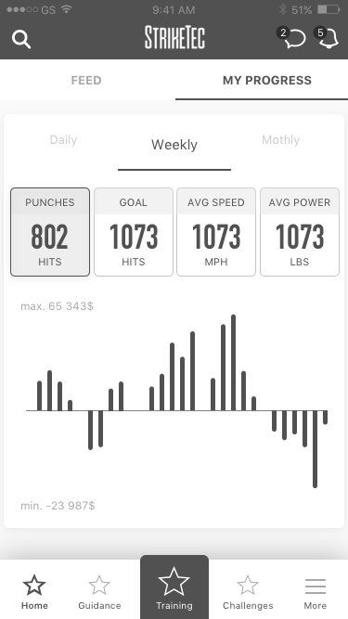

this is current user’s training status with daily, weekly, monthly

******API******

Current App is retrieving data from local db, we need to make api to get this info from server.

Figure 16. Home-MyProgress

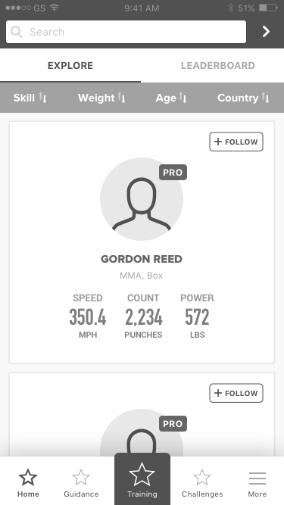 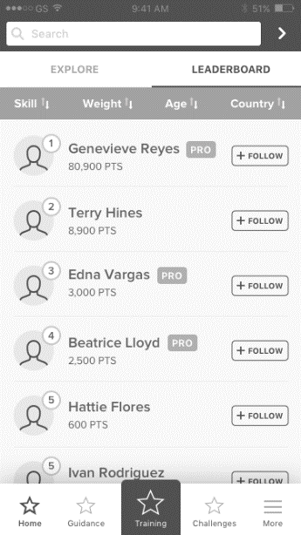

These screen is explore and leaderboard screen.

the contents are same, but user can see detailed info in explore.

user can follow people here.

User can press Skill, Weight, Age, State and list will be sorted in ascending or descending order. Default is Ascending, user clicks 1 time and it will sort descending, click again and back to ascending.

click right arrow beside search field and user will search for name typed into field.

third screen is search result screen.

click user profile image will go to this user’s profile(Figure 53. Other users Profile).

*** api ***

* get all users from leaderboard.
* search users with name
* follow user

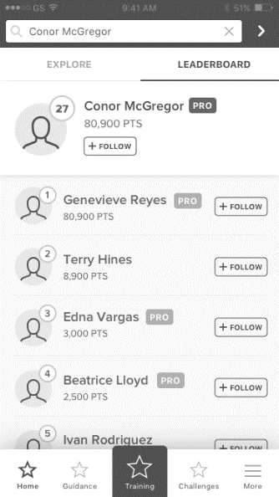

Figure 17. Home-Explore&Leaderboard

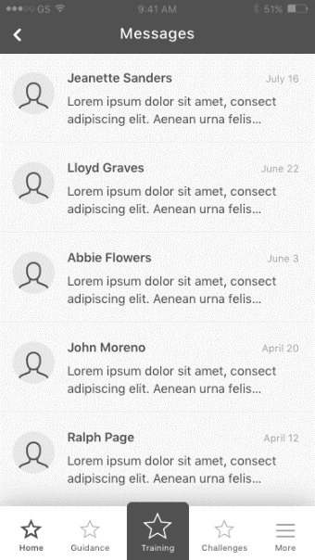 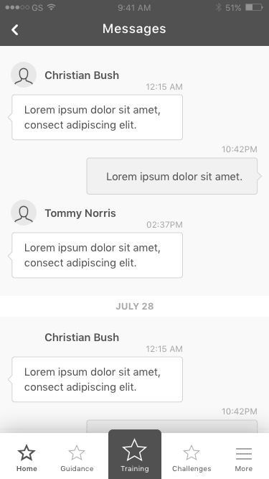

This is Message Screen.

First screen is recent screen.

Click left arrow, will be back to before screen.

Messages are only sent between connections

*** apis ***

* retrieve recents history (will be sorted with time or unread messages)
* load chat history in private chat

Figure 18. Message Screeen

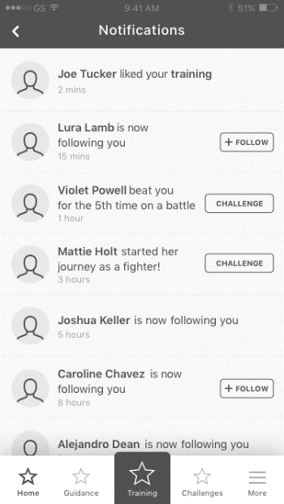

This is notification screen.

Notifications will include some info like when other user follow this user, following user start training, other user send connect request, battle request from other users, Battle Completed by other user …

here user can follow user, accept/decline connect request, or something.

*** api***

* get notifications api

notification object will include notification type , like connect notification, follow notification, …

Figure 19. Notification Screen

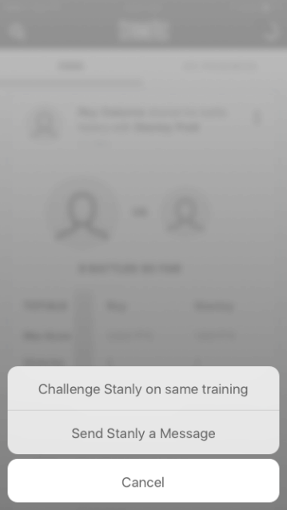

Figure 20.Challenge, Chat Dialog

### Guidance

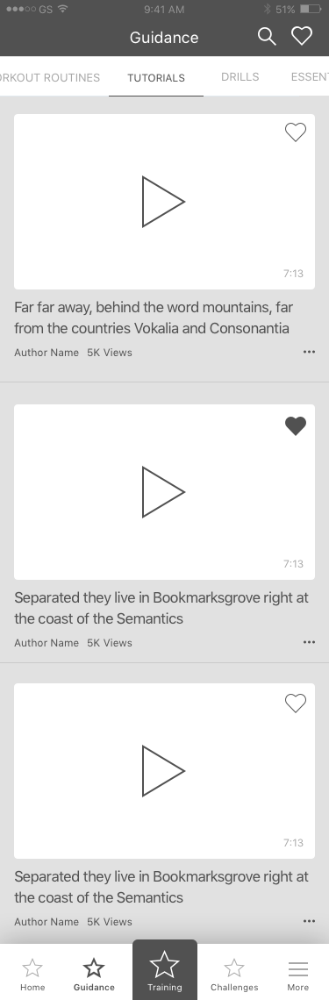

This screen is Guidance Page.

app will get videos from server with description and duration , …

click search icon, then search bar will be showed and query videos .( Figure 23. Search Video Screen)

click each video play icon, will go to video play screen.(Figure 22. Video Play Screen)

*** api ***

api will have start position and count as parameter.

this videos will be uploaded through dashboard, or currently we can upload them to server manually.

Favorite/unfavorite api for each video.

Figure 21. Guidance

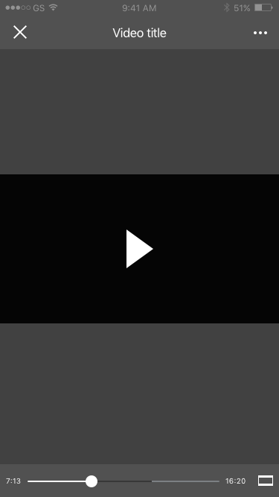

This is video Play Screen

Will show video title, duration from info which is received from server.

Figure 22. Video Play Screen

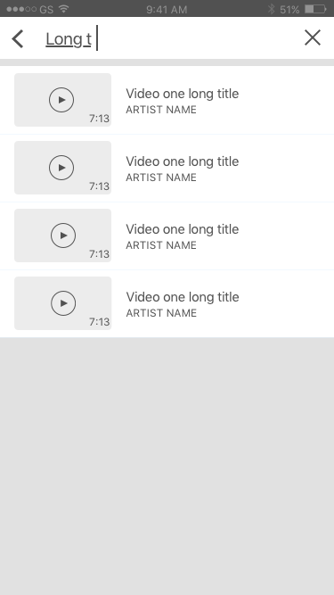

This is Video Search Screen.

Search query with video title

Click each row , will show video play screen.(Figure 22. Video Play Screen)

Figure 23. Search Video Screen

show Favorite Videos.

Click each row , will show video play screen.(Figure 22. Video Play Screen)

User clicks Left Arrow and it returns to (Figure 21. Guidance)

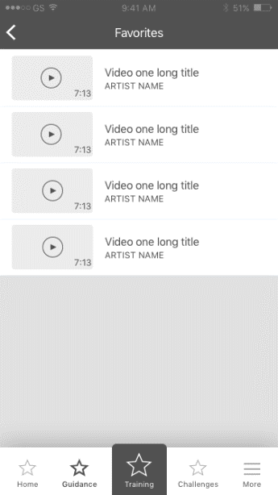

Figure 24. Favorite Video Screen

### Training

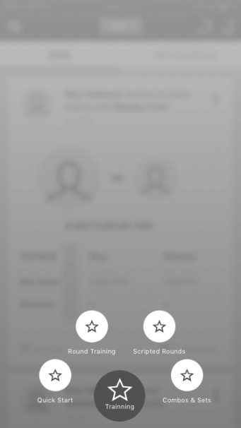

This is training screen.

click “Quick Start”, will go to quick start settings page.(Figure 26. Quick Start Preset Screen)

click “Round Training”, will go to round straining settings page.(Figure 27. Round Training Preset Screen)

click “scripted rounds” will go to workout page.(Figure 28. Scripted Rounds Page)

click “combo&set”, will go to combo set training screen.(Figure 29. Combo Sets Screen)

Figure 25. Training Screen

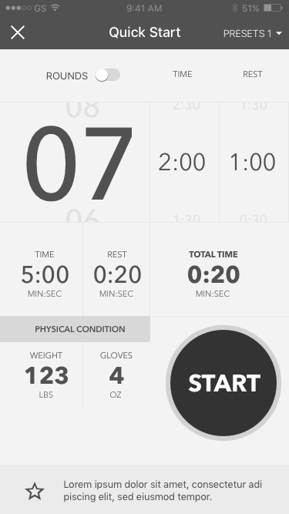

This is Quick Start Preset Screen.

Click “Start”, will go to training screen.

Figure 26. Quick Start Preset Screen

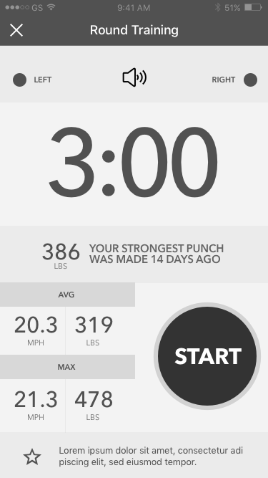

This is Round Training Preset Screen.

Click “Start”, will go to round training screen.

Figure 27. Round Training Preset Screen

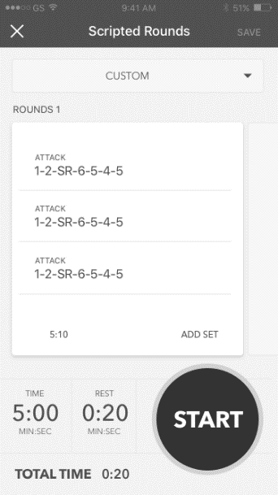

This is Workout Screen.

we will have workout plans from server.

for free plan, a few workout will be available, but user purchased monthly, or annual plan, then lots of workout will be showed.

User can start training by selecting one of them.

Editing workout will not be allowed.

Figure 28. Scripted Rounds Page

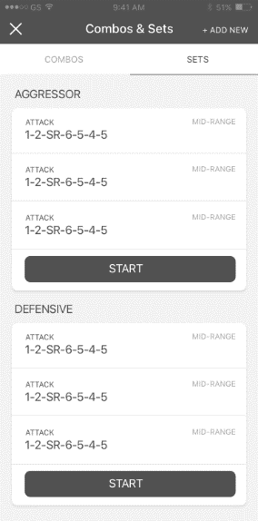

This is Combo Set Screen.

Will have a few combo*set plans for free plan.

Like workout, will have more plans if user purchase items

add new combos and sets are not allowed.

Figure 29. Combo Sets Screen

### Challenge

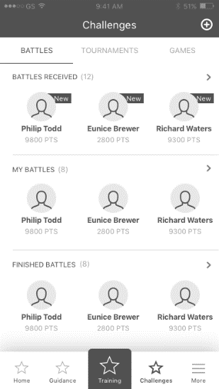

This is Challenge Battles Screen.

“Battle Received”, will show received battles from other fighters, click this will go to received battles screen.(Figure 31. Received Battles)

click any item, will go to accept/decline screen.(Figure 34. Battle Detail Screen)

My Battles are battles which are sent to other users.(Figure 32. Sent Battles)  
Finished are battles which are finished.(Figure 33. Finished Battles)

click any item in finished battles, will go to battle result screen.(Figure 35. Battle Result Screen)

click “+” button, will go to new battle screen.

Figure 30. Challenge Main Screen

This is Received Screen.

will show all list of other user’s request.

user can accept/decline battle request.

Click each row, will go to battle detail screen.(Figure 34. Battle Detail Screen)

*** api***

* get all received battles api.
* decline battle api
* accept battle api

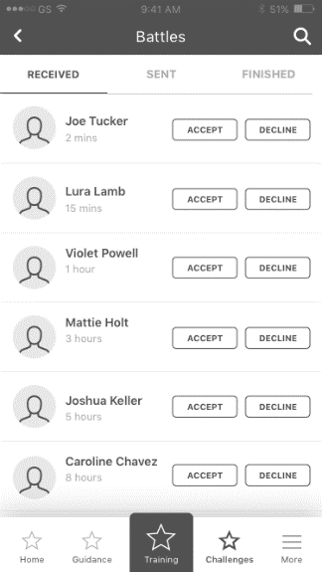

Figure 31. Received Battles

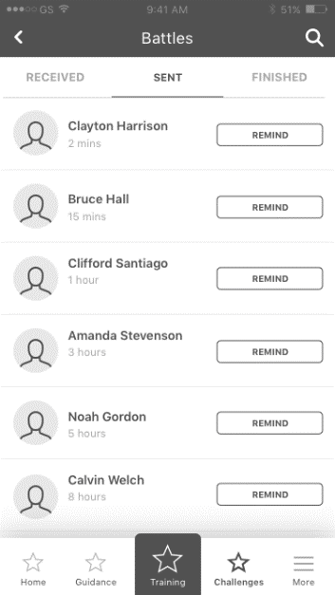

This is sent Battles screen.

This is the list of battles which are sent by current user.

****API *****

set when user presses “remind” , resends the invitation to battle

Figure 32. Sent Battles

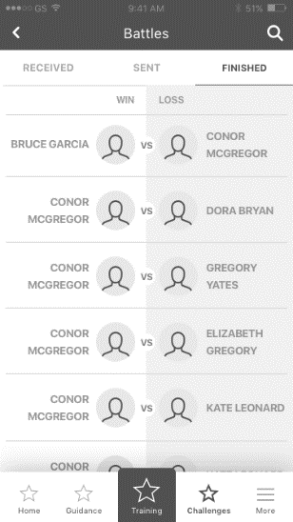

This is finished battles screen.

Will show all finished battles with this user.

Click each row, will go to battle result screen.(Figure 35. Battle Result Screen)

***api***

Retrieve all finished battles.

Figure 33. Finished Battles

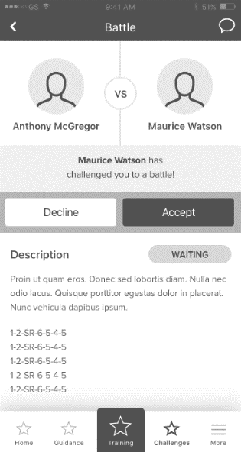

This is Battle Detail Screen.

User can accept/decline battle, can see battle details.

when accept battle, if user’s plan is free plan, then will go to “Purchase Battle” screen. If users plan is all used, user will be directed to (Figure 39. Battle Purchase)

(Figure 39. Battle Purchase)

api Is needed

Figure 34. Battle Detail Screen

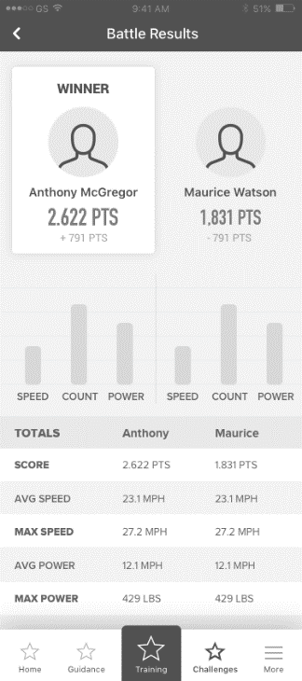

This is Battle Result Screen.

Server will determine who is winner.

api is needed for detailed training result.

Figure 35. Battle Result Screen

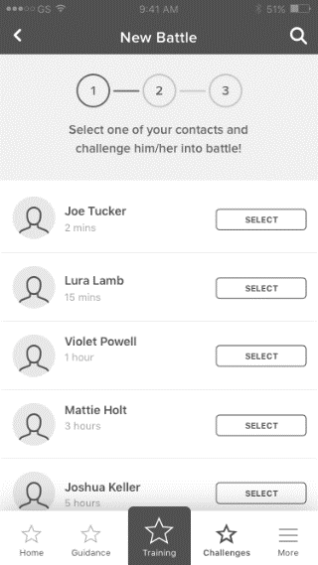

This is new battle screen.

app will show all friends as list and user can select opponents in this screen by clicking “Select Button”

if user click “Select”, then will go to select plan screen.(Figure 37. Select Battle Content Screen.)

Figure 36. New Battle Screen

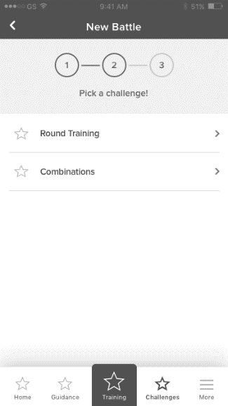

This is battle content screen.

User can select battle content from combo/set/workout

will go to edit description screen(Figure 38. Battle Description Screen.)

Figure 37. Select Battle Content Screen.

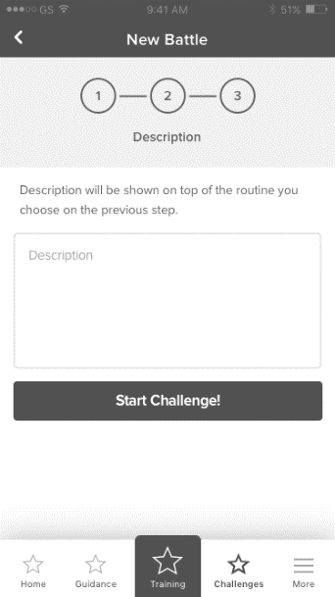

Battle Description Screen.

User can’t edit description.

api to send battle request.

Figure 38. Battle Description Screen.

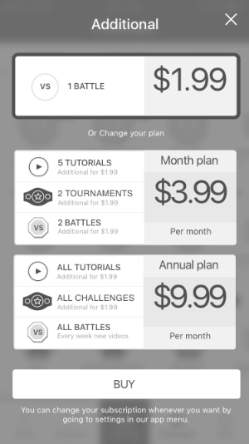

Purchase Screen for one Battle.

will have api to make server know this user is purchased for this battle.

Figure 39. Battle Purchase

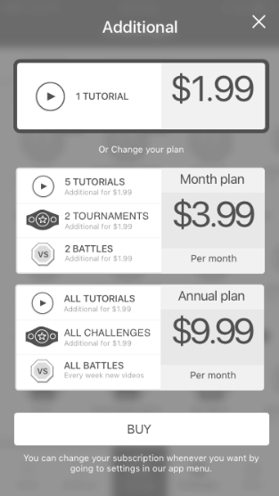

Purchase Screen for one Tutorial.

will have api to make server know this user is purchased for this tutorial.

Figure 40. Tutorial Purchase

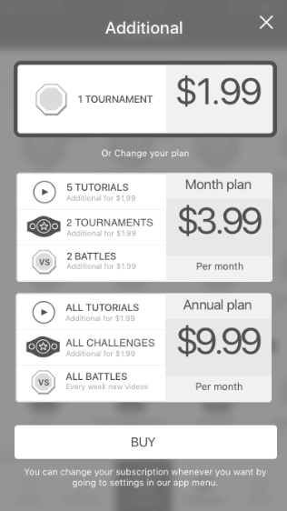

Purchase Screen for one Tournaments.

will have api to make server know this user is purchased for this tournament.

Figure 41. Tournaments Purchase

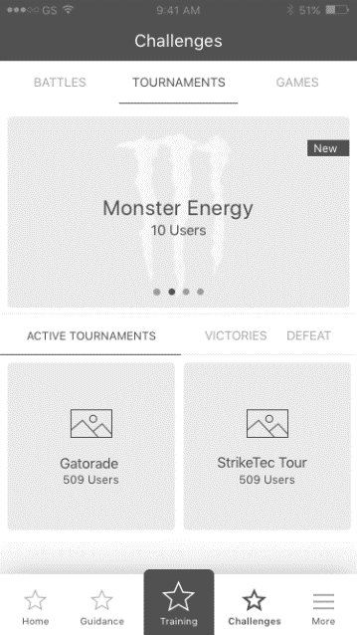

This is Tournaments Main Screen.

Click item, will go to Tournament Detail Screen(Figure 45. Tournament Detail Screen)

Figure 42. Tournament Screen

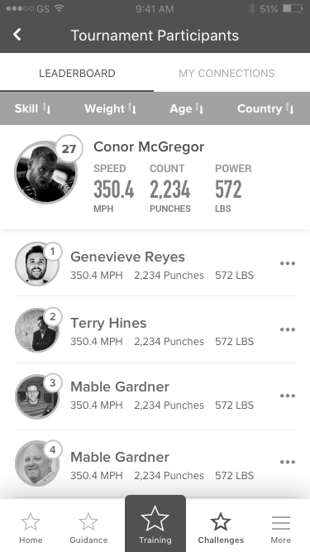

Leaderboard Screen.

Will show leaderboard and if current user is in leaderboard then has to show current user at the first row with rank.

api to get leaderboard.

Figure 43. Tournament Leaderboard Tab

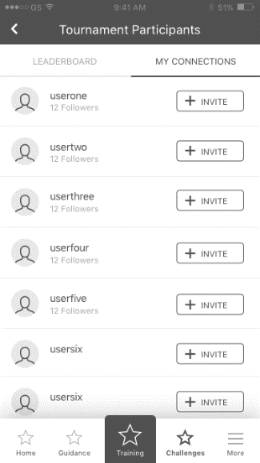

My Connections Screen.

Will show all connections and user can invite them to tournaments.

api is needed.

Figure 44. Tournament My Connection Tab

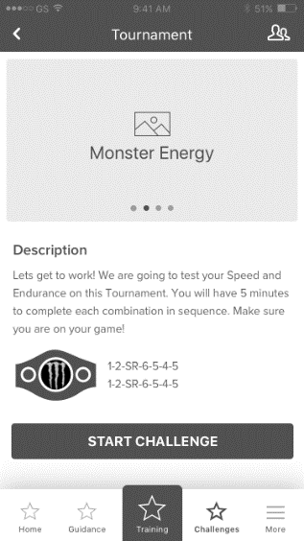

This is Tournament Detail Screen.

It will show tournament detail which can be get from server.

If user click “User” icon, then will go to lead board screen.(Figure 44. Tournament My Connection Tab)

Figure 45. Tournament Detail Screen

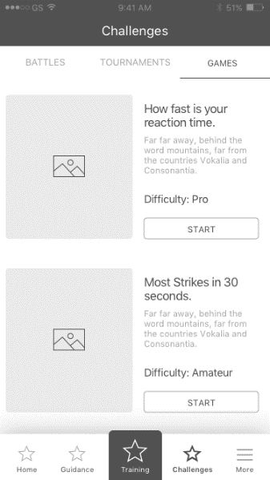

This is Game Tab.

Figure 46. Game Tab

### More

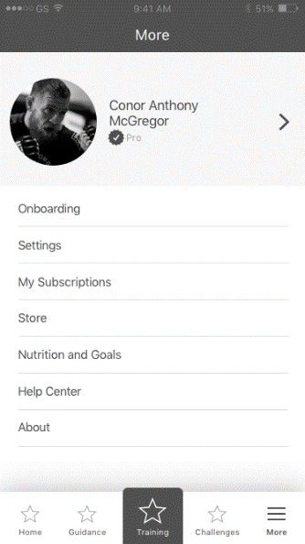

User’s main profile screen.

click profile image row, will go to detail screen.(Figure 54. Detailed Profile Screen)

click settings, will go to user settings page(Figure 48. Settings Screen).

click subscription will go to subscription page (Figure 49. Subscription Screen)

click Store will go to store page(Figure 50. Store Screen)

click “Nutrition and Goals” (will go to other app using API – TBD)

click “Help Center” will go to “Help Center”(Figure 51. HelpCenter Screen)

click “About” will go to “About Screen”(Figure 52. About Screen)

Figure 47. More Screen

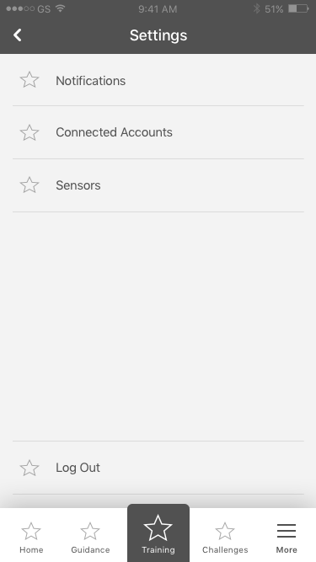

click “Notifications” will go to notification settings screen(Figure 55. Notification Settings Screen).

click “connected accounts”, will go show social accounts(Figure 56. Connected Accounts Page)

click “sensors”, will go to sensor manage screen(Figure 57. Sensor Manage Screen).

Figure 48. Settings Screen

This is my subscription page.

user can manage plans here.

after purchase items, app will call api , so that server will know this user purchased items for plans and will update plans in server.

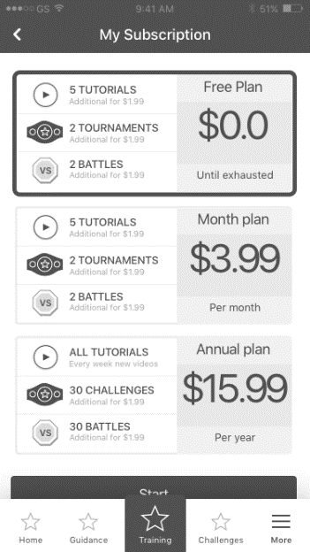

Figure 49. Subscription Screen

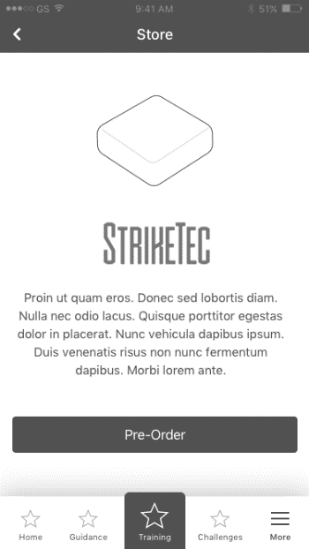

Click Pre Order will go to website to buy sensors.

Figure 50. Store Screen

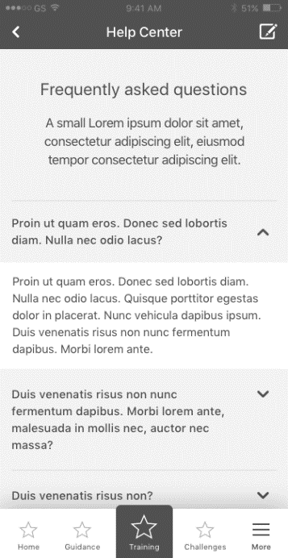

Help Center page.

api to retrieve current user’s feedback or something like questions or answers.

Figure 51. HelpCenter Screen

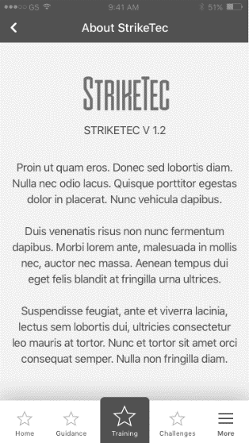

About page.

api is not needed.

Figure 52. About Screen

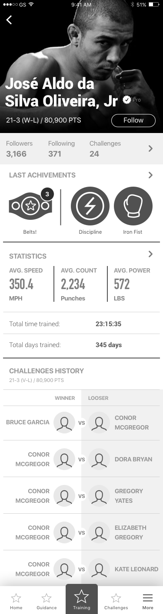

User can see other user’s profile.

can follow/unfollow user in this screen.

need api to get other user’s info

(challenge history, statistics)

if other user set his achievement, statistics, challenge history option as Private (Public View OFF) in edit profile page(Figure 63. Edit profile Screen), then these area will not be showed.

Figure 53. Other users Profile

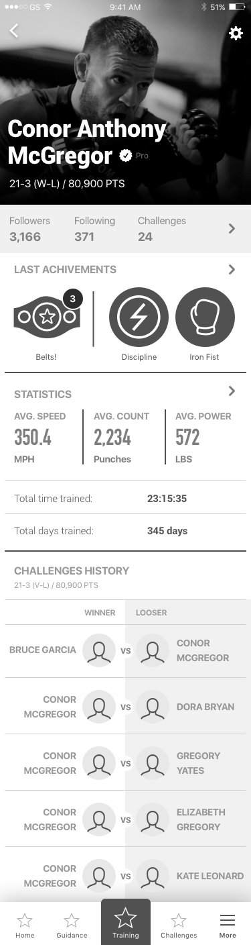

current user’s profile.

if this user is spectator user, then some fields will be removed.(like challenges, last achievements, statistics, challenges history)

Click settings icon in top-right corner of screen, will go to edit profile screen.

Click “followers, following, challenges”, will go to social screen(Figure 60.Social Followers Screen, Figure 61. Social Following Screen, Figure 62. Social Challenge Screen).

Click “Statistics” will go to statistics page.(Figure 58. Statistics Screen)

Click “Last Achievements”, will go achievements page.(Figure 59. Acheivement Screen)

in Challenges History, api will has parameter like start position and count.

if scroll down in app, app will send request with these parameter.

so first call will be start=0, count = 25

if scroll is arrived , then start = 25, count = 25, ….

Figure 54. Detailed Profile Screen

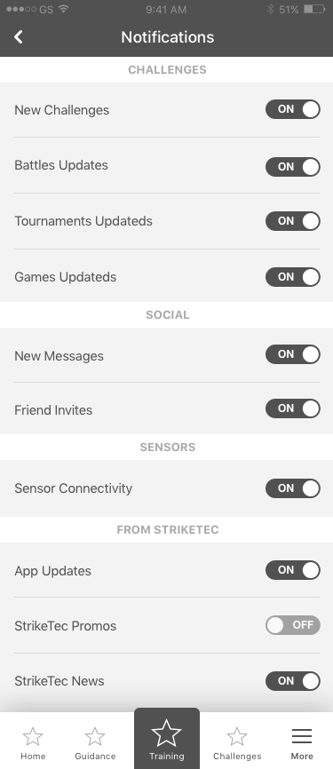

Set Notification settings.

server will save these settings, and according to this option, server will send notification to user.

api is needed here to update user settings.

Figure 55. Notification Settings Screen

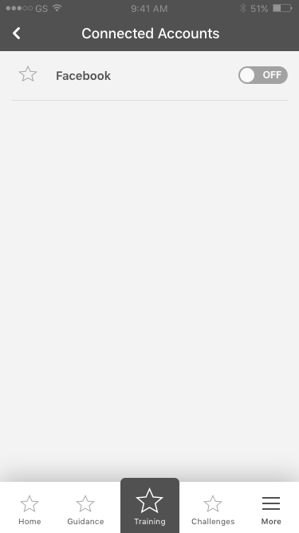

Figure 56. Connected Accounts Page

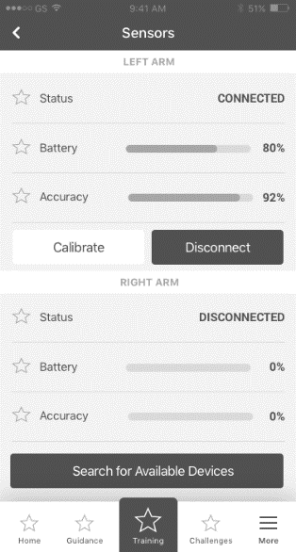

click Disconnect, will disconnect current connected sensors.

click Search available sensors will go to find sensors screen.(Figure 10.Connect Wearable Screen)

Figure 57. Sensor Manage Screen

Statistics Screen.

Will show current user’s training result.

api is needed to retrieve current user’s training info with daily, weekly, and monthly.

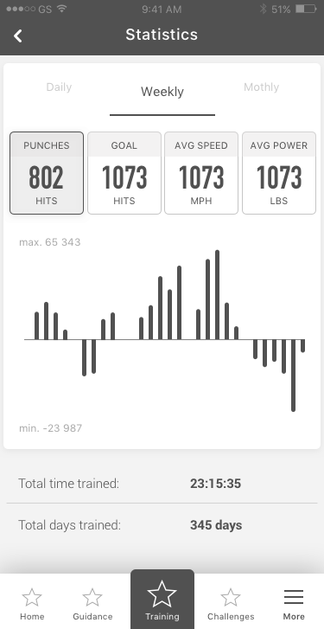

Figure 58. Statistics Screen

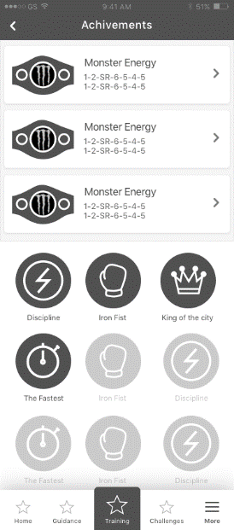

Figure 59. Acheivement Screen

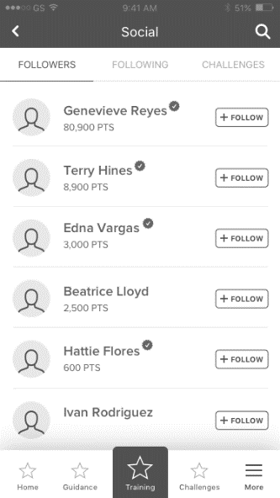

Social Follower Screen.

This screen is the list of users who are following current user.

User can follow them by click “follow” button.

APi will be implemented to follow other user.

Figure 60.Social Followers Screen

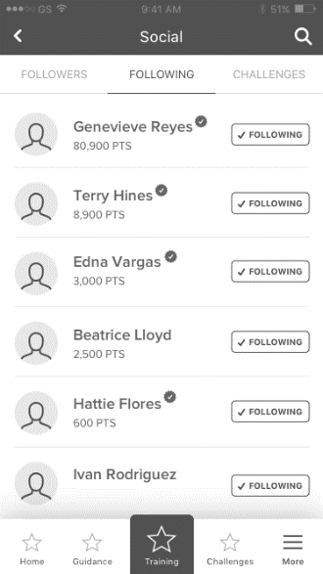

Social Following Screen.

This screen is the list of users who are followed by current user.

api is needed to retrieve all following users.

Figure 61. Social Following Screen

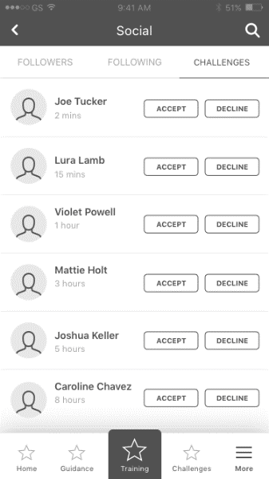

Social Challenge Screen.

In this screen, user can accept or decline other user’s request. If user presses “decline” the battle is deleted.

for Spectator user, will not see any request.

*** api ***

accept/decline challenge request is needed.

Figure 62. Social Challenge Screen

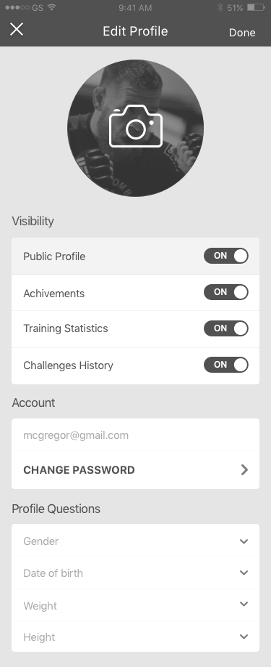

Edit Profile Screen.

click camera icon, will show dialog to take photo from camera or gallery.

public profile option: will make this profile as public or private.

if private, other user’s will not see training results of this user.

for achievements, training statistics, challenges history are the same.

if private, other user’s will never see his profile.

user can’t change email account, but can change password .(Figure 6.Reset Password)

when click change password, will go to change password screen.

Profile questions is for edit his body properties.

when click “Done”, app will call update profile api to update this data in server.

*** api ***

profile image will be uploaded with multi-part and public url will be saved in server db table.

Figure 63. Edit profile Screen

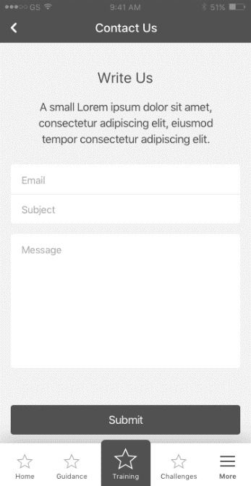

Contact Us page.

user will give feedback or something.

this can be happened in Help Center.

Figure 64. Contact Us